**Twitter style navbar in CSS**

* All the unordered list do have an explicit padding and margin.

**Quote by Pranav Mistry:**

“The mind is not a vessel to be filled, but a fire to be kindled.” [#Plutarch](https://x.com/hashtag/Plutarch?src=hashtag_click) [#curiosity](https://x.com/hashtag/curiosity?src=hashtag_click).

My take:  
While learning, instead of filling yourself with content/matter taught by instructor, kindle, think & question why certain things are happening and how they are happening in that particular way.  
for ex: Let us suppose there is a rectangular box with unordered lists as vertical navbar elements. If there is considerable breathing space on 4 sides inside that rectangular box, then that space is due to padding being explicitly introduced inside rectangular box’s body selector.

* Properties to be considered while styling a body of rectangular box.

* While trying to style unordered lists as navbar elements, we need to first know, which properties come under a particular unordered list’s HTML elements, then select precisely and style them accordingly.

* We can select “ul” HTML element and remove list’s bullet points, their padding and margin.

* Select the “li” list item element and add margin-bottom for each li element.

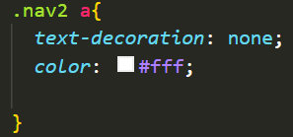

* Select the “a” tag and remove the underline effect by setting “text-decoration:none;” and set the color to white.